RGB Animation Laser
User Manual

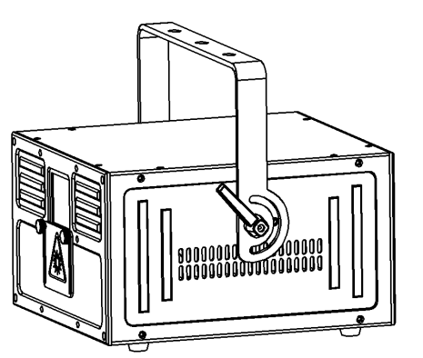

Please read this manual carefully before use!

Contents

Introduction--------------------------------------------------------------------------------------------P2

Silkscreen on product------------------------------------------------------------------------------P3

Safety instruction/Installation/Technical specification----------------------------------P4

Rear panel/MENU-------------------------------------------------------------------------------------P5

DMX512 Channel-----------------------------------------------------------------------------------P6-7

DMX512 connection/DMX address setting---------------------------------------------------P8

Ringing------------------------------------------------------------------------------------------------- P9

Cleaning and maintenance----------------------------------------------------------------------P10

Warning/Warranty card---------------------------------------------------------------------------P11

Introduction
Thank you for purchasing this product. To optimize the performance of this product,prior to use,please read these operating instructions carefully to familiarize yourself with the basic operation of this unit.Please keep the manual in safe price for future reference.
This unit has been tested at our factory before being shipped to you, there is no assembly required.
Once after received this product , please take and put carefully. And check cautiously that whether the product was damaged or not during the transportation.

Checking Parts
Please check if the following parts are included:
1 x Laser light
1 x User manual
1 x Power cable

Caution



CAUTION!

Keep this device away from rain and moisture!

Unplug mains lead before opening the housing!

Warning!


Damages caused by the disregard of this user manual are not subject to warranty. The dealer will not accept liability for any resulting defects or problems.

Symbol Instruction On The Device

…


-------------------------------------------------------------------------------CE Certificate
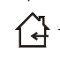

---------------------------------------------------------------------Only indoor use


------------------------------------------------------------------------Environmental protection

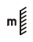
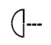
----------------------------------------The minimum distance from lighted objects(meter)

------------------------------------------------------------Max. Ambient Temp

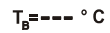
----------------------------------------------------Max. Housing Temp



------------------------------------------------------------------------- Safety caution

Safety Instructions
- Please open and check whether break or not for transport once receive this fixture, if yes, not use it and contact dealer or manufacture as soon as possible.
- The Max applicable temperature for the light is 40°C. Do not use the light under or above the temperature. ta=40℃
- The fixture is applicable for many occasions, it should keep clean, and avoid long use in overheating or dusty environment. To prevent the fixture from the chemical liquid .
- User must be careful of fire, heat, electric and fall-off that make heavy or fatal injury. Please read this user manual carefully before power on and installation, following safety and operation instruction in it. If still have any questions, please contact dealer or manufacture.
- User must following this user manual, do not open fixture by yourself, if any problems, please contact professional technician, maintenance should by technician.
Do not power on or start the fixture before installation, please stop after working more than 8 hours, which will longer use life.
- Fixed installation, do not by strong shocks.
- The minimum distance between light and the illuminated surface must be more than 1 meter. 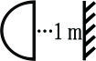
- Never look directly into the light source to avoid hurt to eyes (especially epileptics)!
When dust-proof glass at light output breaks, cracks or other visible damage, user should replace with new glass to continue to use.

Installation
- When install this equipment please make sure there's no flammable surfaces (decorated things, etc) and minimum distance of 0.5M from the equipment to the flammable.
- The installation of the effect has to be built and constructed in a way that it can hold 10 times the weight and without any harming deformation.
- The installation must always be secured with a secondary safety attachment, e.g. an appropriate safety rope.Never stand directly below the device when mounting, removing or servicing the fixture.

Technical Specifications
Input voltage: AC100-240V, 50/60Hz
Fuse: BGDP ￠5x20mm 250VAC F2A
Total power:120W
Light source:12W
Control mode: Auto/Sound/DMX512/ILDA/Master-slave/SD
Channels: 17CH
Built-in patterns: 117 patterns
Scanning system:30Kpps scanner
Display: 2.4ft TFT color display
IP rating: IP20
Beam angle:±20º
Surface temp: Tb=45ºC ( this data testing when the environment temp is 30ºC)
Working temp: 10ºC--40ºC
Modulation: TTL
N.W: 7.5Kg
G.W: 8.2Kg
Outer packing size: 39*33*25.5cm

Rear panel

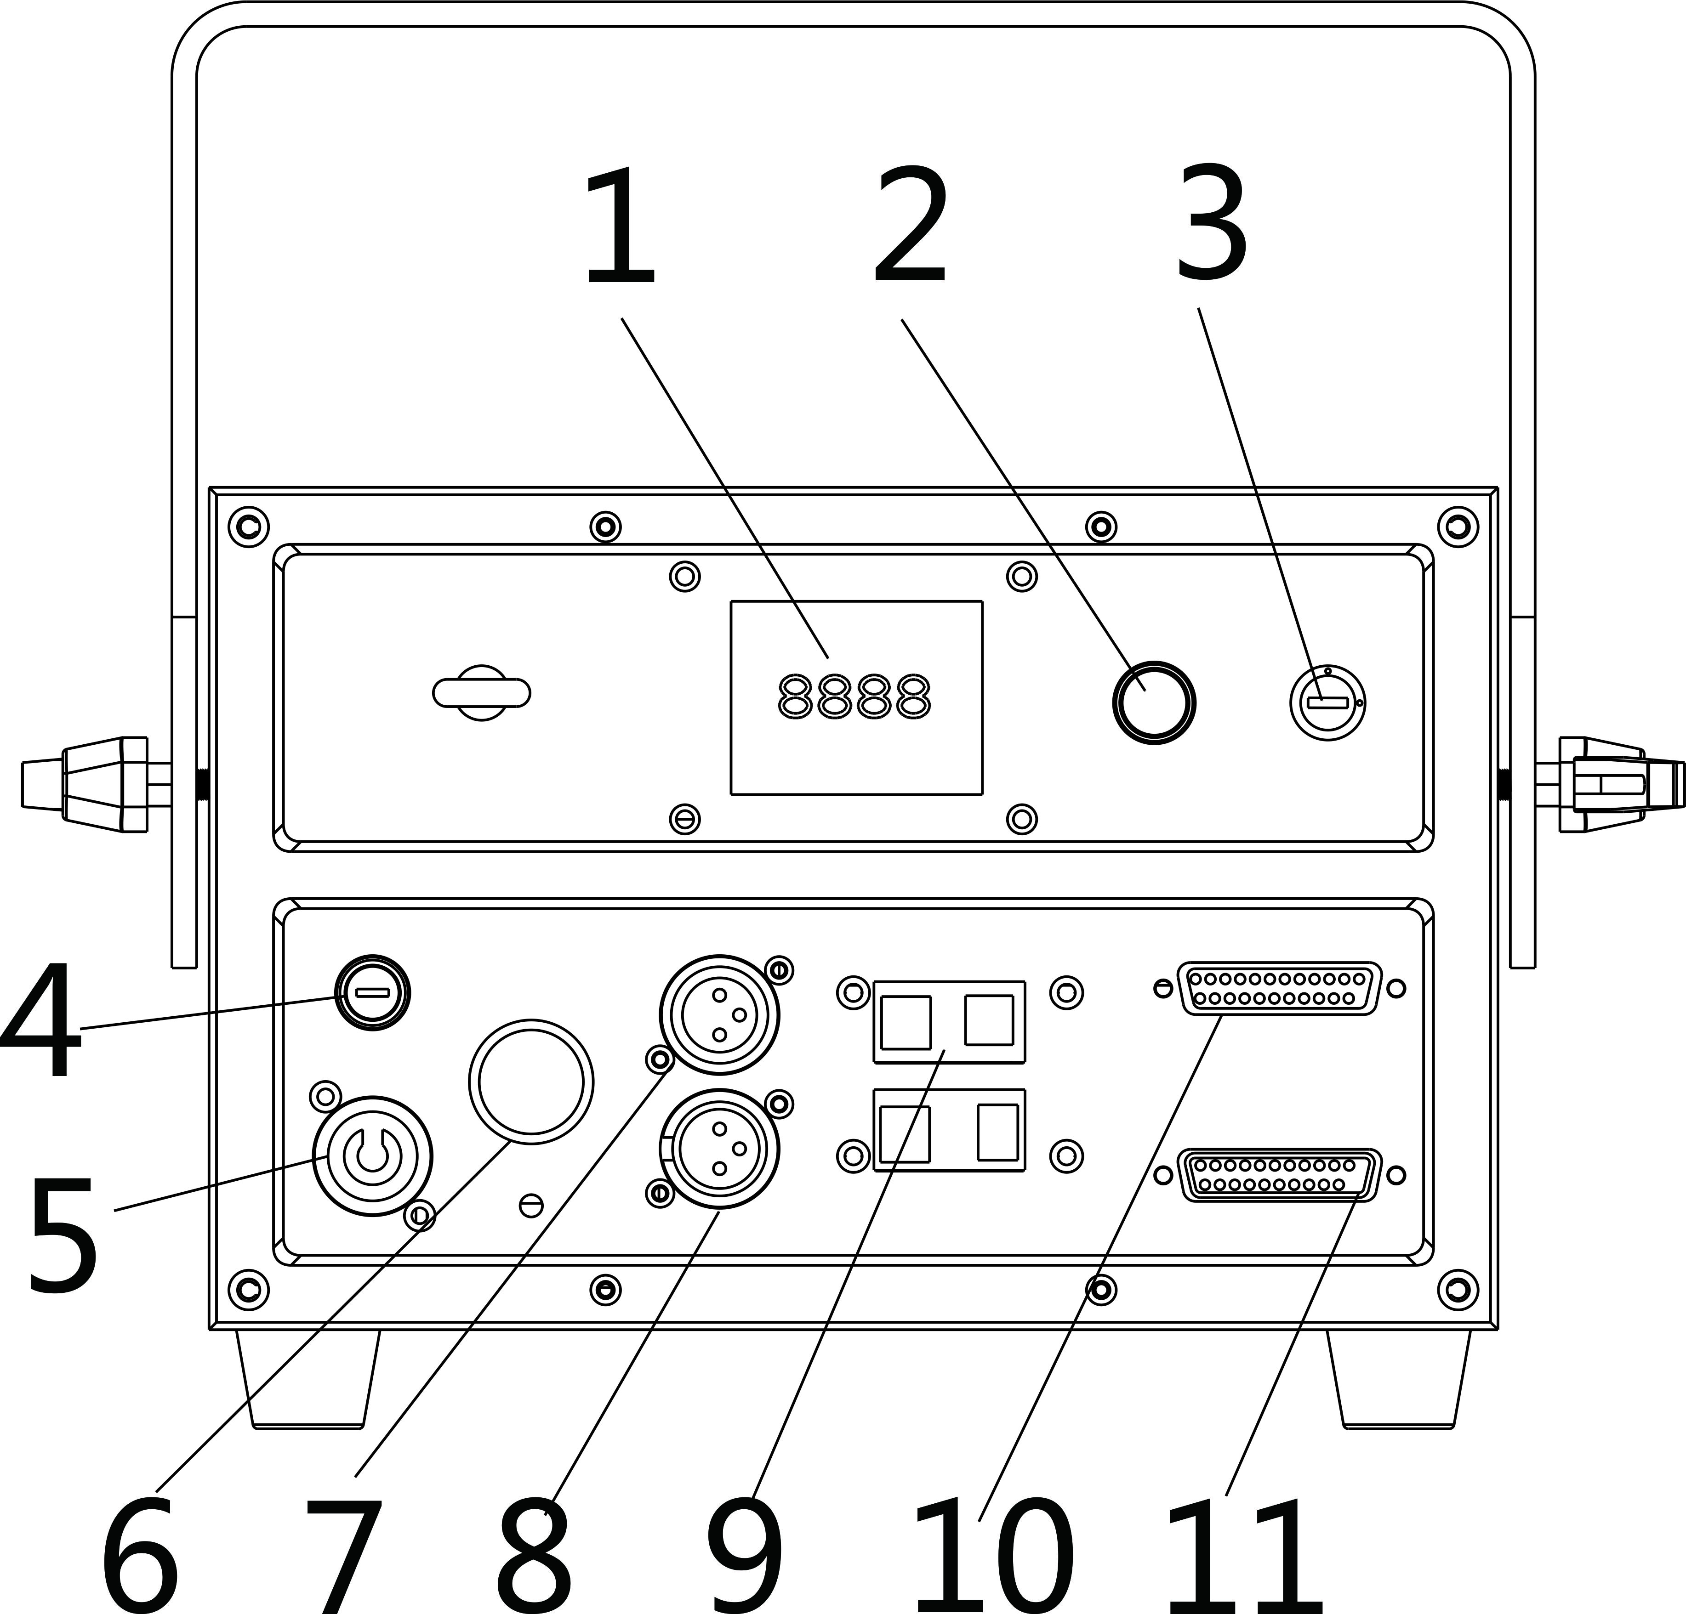

1: display | 5: power input | 9: ILDA-RJ45/DMX-RJ45
2: knob | 6: power switch | 10: 25-pin ILDA signal output
3: key switch | 7: DMX signal input | 11: 25-pin ILDA signal input
4: fuse | 8: DMX signal output

MENU display
MENU | Display | Function
Dmx Address | 1-512 | DMX address setting
Show mode | Prg Mode | Display list mode：run PRG file, the 2rd line displays the current file name
Show mode | ILDA Mode | ILDA mode，run shows in ILDA file circularly（file’s expanded-name is ILD）
Show mode | sound mode | no function
Show mode | Auto Mode | Auto mode, run the built-in programs
Program | program1/2/3 | program1/2/3 for auto mode
SD File | no SD | inset SD card to run files in SD card, can update program too.
Size | 0-100 | Set pattern size
Phasic Invert | X+ Y+ | set Phase, press UP or DOWN to set the data
Phasic Invert | X- Y+ | set Phase, press UP or DOWN to set the data
Phasic Invert | X- Y- | set Phase, press UP or DOWN to set the data
Phasic Invert | X+ Y- | set Phase, press UP or DOWN to set the data
scan speed | 15-40K | set the data according to scanner speed, don't set too high data, it will break the scanner
NO DMX state | show mode | light run shows when no DMX signal
NO DMX state | blackout | light keeps black when no DMX signal
SLAVE MODE | Slave | Slave mode，receive the master unit’s signal and work synchronously
SLAVE MODE | Maste | Master mode, during operation, output the master unit’s signal to slave unit, set only 1 light as master unit.
X Phase | Positive/Reverse | set X Phase: positive/reverse
Y Phase | Positive/Reverse | set Y Phase: positive/reverse
Laser Lock | On/Off | set laser lock ON/OFF
Sound Sense | 0-100 | sound sensitivity, no this function
SD Sound | On/Off | set sound activated for SD files, no this function
red dimmer | 0-100 | red dimmer 0-100%
green dimmer | 0-100 | green dimmer 0-100%
blue dimmer | 0-100 | blue dimmer 0-100%
LOAD FLASH | On/Off | load FLASH program, need insert SD card
ILDA | On/Off | set RJ45-ILDA function，please set ILDA ON before set ILDA function

Remarks: Rotate the knob at display’s right side to operate the menu, press knob to enter sub-menu or exit menu, after operation, double-click the knob to save the option and exit the menu.

DMX Channel Instructions

Channel | Function | Value | Details
CH1 | control mode | 0-49 | auto mode
CH1 | control mode | 50-99 | sound activated mode
CH1 | control mode | 100-149 | run PRG file orderly
CH1 | control mode | 150-199 | run ILD file circularly
CH1 | control mode | 200-255 | manual mode
CH2 | choose pattern/file | 0-255 | choose single pattern in manual mode | PRG/ILD mode
CH2 | choose pattern/file | 0-255 | choose pattern, 1 pattern for 3 digits | 117 patterns in total
CH3 | strobe and display file | 0-10 | no strobe | run signal pattern, 117 patterns in total
CH3 | strobe and display file | 11-199 | strobe automatically from slow to fast | run signal pattern, 117 patterns in total
CH3 | strobe and display file | 200-255 | strobe via sound activated | run signal pattern, 117 patterns in total
CH4 | choose color | 0-5 | laser off
CH4 | choose color | 6-16 | white | ILD file's original color
CH4 | choose color | 17-33 | red
CH4 | choose color | 34-50 | green
CH4 | choose color | 51-67 | blue
CH4 | choose color | 68-84 | yellow
CH4 | choose color | 85-101 | purple
CH4 | choose color | 102-118 | cyan
CH4 | choose color | 119-135 | white,red, green, blue subsection
CH4 | choose color | 136-152 | blue, yellow, purple, cyan subsection
CH4 | choose color | 153-169 | white, red, green, blue, yellow, purple, cyan subsection
CH4 | choose color | 170-186 | white, red, green, blue color flowing
CH4 | choose color | 187-203 | blue, yellow, purple, cyan color flowing
CH4 | choose color | 204-220 | white, red, green, blue, yellow, purple, cyan color flowing
CH4 | choose color | 221-237 | color subsection by pattern break-point
CH4 | choose color | 238-255 | color change by sound
CH5 | display | 0-63 | normal display | this function is available only at manual mode
CH5 | display | 64-127 | bright dot display | this function is available only at manual mode
CH5 | display | 128-191 | subsection display | this function is available only at manual mode
CH5 | display | 192-255 | dot display | this function is available only at manual mode
CH6 | X move | 0-255 | move by manual adjustment | when a pattern move to a dot, the laser diode OFF, for normal use, please set channel data as 127
CH7 | Y move | 0-255 | move by manual adjustment
CH8 | Zoom | 0-10 | no zoom
CH8 | Zoom | 11-87 | zoom by manual adjust
CH8 | Zoom | 88-150 | zoom out
CH8 | Zoom | 151-200 | zoom in
CH8 | Zoom | 201-255 | zoom circularly
CH9 | Horizontal rotation | 0 | no rotation
CH9 | Horizontal rotation | 1-128 | manual adjust
CH9 | Horizontal rotation | 129-255 | auto rotation
CH10 | Vertical rotation | 0 | no rotation
CH10 | Vertical rotation | 1-128 | manual adjust
CH10 | Vertical rotation | 129-255 | auto rotation
CH11 | center rotation | 0 | no rotation
CH11 | center rotation | 1-128 | manual adjust
CH11 | center rotation | 129-192 | auto rotation clockwise
CH11 | center rotation | 193-255 | auto rotation anti-clockwise
CH12 | gradual drawing | 0-10 | no drawing
CH12 | gradual drawing | 10-74 | gradual drawing by manual adjust
CH12 | gradual drawing | 75-104 | auto gradual drawing （increasing）
CH12 | gradual drawing | 105-144 | auto gradual drawing （decreasing）
CH12 | gradual drawing | 145-184 | auto gradual drawing circularly
CH12 | gradual drawing | 185-224 | end to end gradual drawing circularly（increasing）
CH12 | gradual drawing | 225-255 | end to end gradual drawing circularly (decreasing）
CH13 | Horizontal wave | 0-9 | no wave
CH13 | Horizontal wave | 10-69 | small wave
CH13 | Horizontal wave | 70-129 | middle wave
CH13 | Horizontal wave | 130-189 | big wave
CH13 | Horizontal wave | 190-255 | biggest wave
CH14 | Vertical wave | 0-9 | no wave
CH14 | Vertical wave | 10-69 | small wave
CH14 | Vertical wave | 70-129 | middle wave
CH14 | Vertical wave | 130-189 | big wave
CH14 | Vertical wave | 190-255 | biggest wave
CH15 | red dimmer | 0-255 | red dimming from 100%-0%
CH16 | green dimmer | 0-255 | green dimming from 100%-0%
CH17 | blue dimmer | 0-255 | blue dimming from 100%-0%

DMX-512 connection
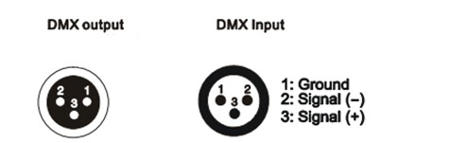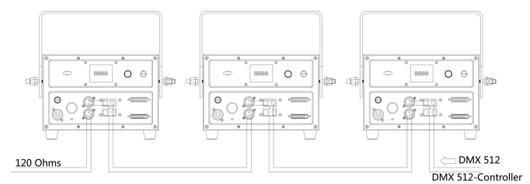

DMX In To the fourth
First light (Address 001) Second light (Address 018) Third light(Address 035)

DMX Address setting
Each fixture must set a specific starting address. When receiving signal transmission, fixture will receive channel control signals which from the starting address.
According to different requirements or easy to use, the user can set many value fixtures to the same address, also can set up a separate address for every device.
If you set the same address,all the devices will receive from DMX channels signal. All connecting fixtures are jointly controlled, controller can't separate control a device.
If you set a different address, each device will be separate from its particular set the starting address and begin accepting DMX512 control signal, so that more convenient separate control one device. Using this method must be based on channel quantity of device to determine a starting address.
This laser light has 17 channels.you should set the starting address of the first unit to 1, the second unit to 18(1 + 17), the third unit to 35 (17*2+ 1), and so on.


Ringing
1 Mounting bracket
2 Handle
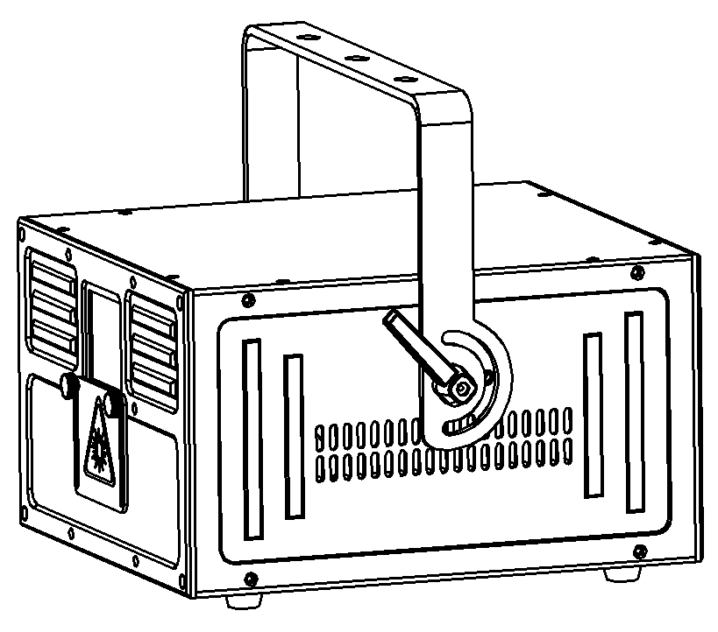

- .The ambient temperature range is 10°C--40°C, must never be exceeded.
- .The installation of the projector has to be built and constructed in a way that it can hold 10 times the weight for 1 hour without any harming deformation.
- ).When rigging or servicing the fixture staying in the area below the installation place, on bridges,under high working places and other endangered areas is forbidden.
D).The operator has to make sure that safety-relating and machine-technical installations are approved by an expert before taking into operation for the first time and after changes before taking into operation another time.
E).The operator has to make sure that safety-relating and machine-technical installations are approved by a skilled person once a year.
F). Sure M8 screws on mounting bracket fixed middle hole ¢12.5mm of handle

Cleaning and maintenance

Maintenance should be performed every 15-day period, by using a sponge which is dipped with alcohol, rather than wet cloth or other chemical liquid, to clean the mirror.

Always disconnect from the mains when the device is not in use or before cleaning it.

Caution
Make sure power off before cleaning and maintenance!

Warning

Warning!
Never look directly into the light source,as sensitive persons may suffer an epileptic shock(especially meant for epileptics)!
Caution

Warning!
Any power connected must by professional person


Warranty Card
This product is made of high-brightness transistor. We will provide 1 year warranty under the condition that user has operated the light normally and lifetime service. We won't provide warranty if the damage is caused by artificial or force majeure event. Cost of fittings should be charged by user if product need maintenance after 1 year .Please cut this warranty card and shipped it along with the product to our factory when applying for warranty.
Product：
Purchasing date：
Code of invoice：
Warranty date: From To
User’s name： Add：
Company： Tel：

